Project Overview Document
RTOS-Based TinyML Environmental Monitoring and Alert System

1. Project Title
RTOS-Based TinyML Environmental Monitoring and Alert System

2. Project Domain
- Embedded Systems
- Edge AI / TinyML
- IoT
- FreeRTOS
- Real-Time Systems
- Firmware Development

3. Objective
The objective of this project is to design and develop a real-time intelligent environmental monitoring system using STM32, ESP32, FreeRTOS, and TinyML.
The system continuously monitors environmental parameters such as:
- temperature,
- gas/smoke level,
- vibration/anomaly conditions,
and performs lightweight machine learning inference directly on the microcontroller using TensorFlow Lite for Microcontrollers (TFLite Micro).
The system uses FreeRTOS for multitasking and ESP32 for wireless MQTT cloud communication.

4. Core Features
Embedded Features
- FreeRTOS multitasking
- Queue-based inter-task communication
- UART communication
- I2C sensor interfacing
- ADC sensor acquisition
- watchdog/reliability support

AI Features
- TinyML inference on STM32
- anomaly detection/classification
- lightweight TFLite Micro model

IoT Features
- ESP32 Wi-Fi communication
- MQTT protocol
- cloud dashboard integration
- remote monitoring

Monitoring Features
- real-time environmental monitoring
- abnormal condition detection
- alert generation
- live sensor visualization

5. System Architecture
+---------------------+
| Sensors |
|---------------------|
| DHT22 / BME280 |
| MQ2 Gas Sensor |
| Vibration Sensor |
+----------+----------+
|
v
+---------------------+
| STM32 |
|---------------------|
| FreeRTOS Scheduler |
| Sensor Tasks |
| TinyML Inference |
| UART Communication |
| Queue/Semaphores |
+----------+----------+
|
UART
|
v
+---------------------+
| ESP32 |
|---------------------|
| ESP-IDF Firmware |
| Wi-Fi Stack |
| MQTT Client |
| Cloud Communication |
+----------+----------+
|
v
+---------------------+
| Cloud Dashboard |
|---------------------|
| Adafruit IO |
| HiveMQ Cloud |
| ThingsBoard |
+---------------------+

6. Hardware Components
Component | Purpose
STM32 Nucleo F401RE | Main RTOS controller
ESP32 Dev Board | Wi-Fi + MQTT communication
DHT22/BME280 | Temperature/Humidity sensing
MQ2 Gas Sensor | Gas/smoke detection
Vibration Sensor | Anomaly detection
OLED Display (optional) | Local status display
Breadboard | Prototyping
Jumper Wires | Connections
Power Supply | System powering

7. Software Stack
STM32 Side
- STM32CubeIDE
- STM32 HAL Drivers
- FreeRTOS
- TensorFlow Lite Micro
- Embedded C

ESP32 Side
- ESP-IDF
- MQTT library
- UART driver
- Wi-Fi stack

ML Side
- Python
- TensorFlow / Scikit-learn
- Jupyter Notebook
- TFLite Converter

8. RTOS Task Architecture
Task Name | Priority | Function
Sensor Task | Medium | Read sensor values
ML Inference Task | High | Run TinyML model
UART Task | Medium | Send data to ESP32
Display Task | Low | OLED updates
Alert Task | High | Trigger alerts

9. FreeRTOS Concepts Used
- Task scheduling
- Task priorities
- Queues
- Binary semaphores
- Mutexes
- Inter-task communication
- Delays/timers
- Stack management

10. Sensor Data Flow
Sensors
↓
Sensor Task
↓
Queue
↓
ML Inference Task
↓
Classification Result
↓
UART Task
↓
ESP32
↓
MQTT Cloud Dashboard

11. Communication Protocols
Protocol | Usage
UART | STM32 ↔ ESP32 communication
I2C | BME280/OLED
ADC | MQ2 sensor
GPIO | Vibration sensor
MQTT | Cloud communication

12. TinyML Model
Recommended Model Type
Start simple:
- binary classification
OR
- anomaly detection

Example Classes
Input Condition | Output
Normal environment | NORMAL
High gas level | ALERT
Excess vibration | ALERT
Temperature anomaly | WARNING

13. Machine Learning Workflow
Data Collection
↓
Dataset Preparation
↓
Model Training
↓
Model Quantization
↓
Convert to TFLite
↓
Deploy to STM32
↓
Inference using TFLite Micro

14. Suggested TinyML Strategy
DO NOT start with image classification.
Start with:
- sensor-based classification
- anomaly detection
Reason:
- much lower RAM usage
- easier debugging
- realistic for STM32 F401

15. Suggested Cloud Platforms
Recommended
- Adafruit IO
- HiveMQ Cloud
- ThingsBoard

Avoid Initially
- AWS IoT
- Azure IoT
Too complex for first version.

16. Example MQTT Payload
{
"temperature": 31,
"gas": 120,
"vibration": 0,
"status": "NORMAL"
}

17. UART Packet Example
<START,TEMP=31,GAS=120,VIB=0,STATUS=NORMAL>

18. Development Phases
Phase 1
STM32 + FreeRTOS setup

Phase 2
Sensor integration

Phase 3
RTOS multitasking architecture

Phase 4
UART communication

Phase 5
ESP32 MQTT integration

Phase 6
TinyML integration

Phase 7
Optimization + testing

Phase 8
Documentation + demo

19. Key Engineering Focus Areas
Reliability
- stable task scheduling
- error handling
- reconnect logic

Memory Optimization
- stack usage
- tensor arena optimization
- flash/RAM monitoring

Debugging
- UART logging
- RTOS debugging
- fault handling

Modularity
- separate drivers
- reusable code
- scalable architecture

20. Folder Structure
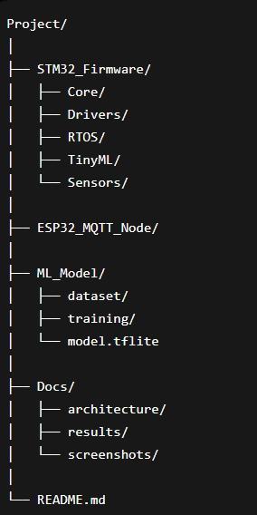
21. Expected Outcomes
The completed system should:
- monitor environmental parameters in real time,
- detect abnormal conditions,
- perform TinyML inference on STM32,
- send alerts to cloud dashboard,
- demonstrate reliable multitasking using FreeRTOS.

22. Technical Skills Demonstrated
Embedded
- STM32 firmware development
- peripheral interfacing
- RTOS design

AI
- TinyML deployment
- TFLite Micro
- embedded inference

IoT
- MQTT
- ESP-IDF
- cloud connectivity

Software Engineering
- modular architecture
- GitHub workflow
- debugging/testing

23. Resume Description
Designed and implemented an RTOS-based TinyML environmental monitoring system using STM32 and ESP32. Developed FreeRTOS multitasking firmware for sensor acquisition, UART communication, and TensorFlow Lite Micro inference. Integrated MQTT cloud communication using ESP-IDF for real-time monitoring and alert generation.

24. Estimated Cost
Item | Approx Cost
STM32 Nucleo F401RE | ₹650–₹900
ESP32 | ₹350–₹600
Sensors | ₹400–₹800
Miscellaneous | ₹300–₹600

Total Estimated Cost
Approximately:
₹1500 – ₹3500
depending on modules already available.

25. Future Improvements
Possible future enhancements:
- OTA updates
- battery operation
- BLE support
- edge vision
- industrial predictive maintenance
- edge dashboard analytics

26. Important Development Advice
DO
- build module-by-module
- test each subsystem independently
- commit to GitHub daily
- prioritize reliability

DO NOT
- integrate everything at once
- overcomplicate cloud infrastructure
- start with camera-based ML
- chase unnecessary features

27. Final Goal
The final project should look like:
- a professional embedded product prototype,
NOT
- a typical college mini-project.
The focus should be:
- architecture,
- reliability,
- debugging,
- RTOS understanding,
- embedded AI integration,
- clean documentation.

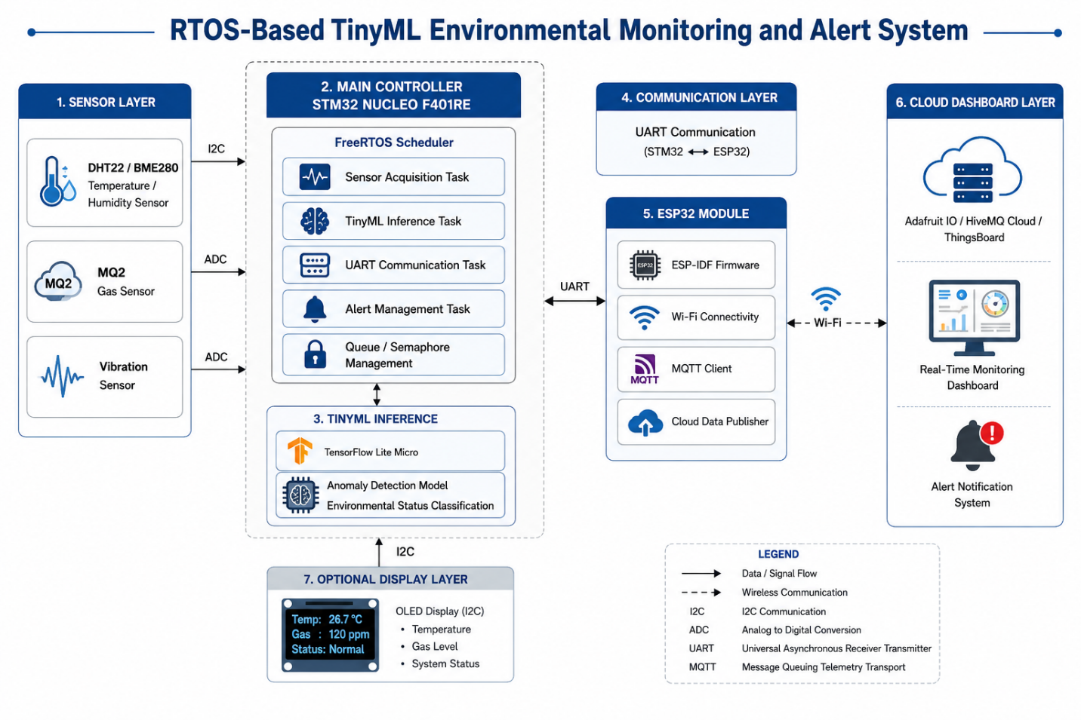

Sensors used
- BME280 Sensor Module
- MQ-2
- SW-420 vibrartion sensor

